Внеклассное мероприятие по английскому языку в 3 классе «English Land»

Цели:

Образовательные :
- В ходе творческой, индивидуальной и групповой работы закрепить знания учащихся по изученным темам («Животные», «Продукты питания» и др.).
- Расширить общий кругозор.

Развивающие :
- Развивать умение работать в коллективе и принимать совместное решение.
- Развивать положительные личностные качества (ответственность, доброжелательность, чувство взаимопомощи).
- Развивать и тренировать внимание, память, мышление.

Воспитательная :
Воспитывать уважение к культуре своей страны и стран изучаемого языка.
Оборудование : раздаточный материал, презентация, компьютер

Ход мероприятия:
- Организационный момент

Good morning, children and our guests! I’m very glad to see you here. Now we’ll organize a competition called “Do you speak English?”. Two teams will take part in our game. The 1st team is “……”. The 2nd team is “……”.
Good morning, children and our guests! I’m very glad to see you here. Now we’ll organize a game “Adventure in space”. We will send some information about us to our friends in space.

- Основной этап

Now I will explain you the rules. You have 5 groups or 5 sectors of questions.

- Food .
- My family
- Grammar practice
- Pets
- Count

- First tusk is write your names and put them into the envelope. Well done!

- Find the odd one in every line. Then put this 5 words in the text to make a story about you and your family.

- Guinea pig, fox, Russia, budgie, kitten
- dog, rabbit, family, bus, brown
- black, orange, green, blue, dad
- Apple, mum, cucumber, cheese, bread
- Eyes, nose, hair, love, ears

I am from …..I’ve got a big…..I have a…… She is nice.I have got a…. He is kind.I …..my family.

- What animals do you know? Read a few riddles and tell me, wat animals these are.
You remember them well, so I think we can make a crossword to sent it to our future friends!

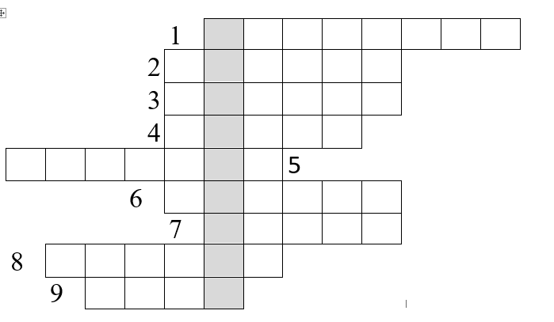

- We need some food to take with us in space. Tell me, what food do you like, don’t like. We can make a recipe to sent in the next envelope.
We have cards with food. Put them on the papers to make a cake and soup.
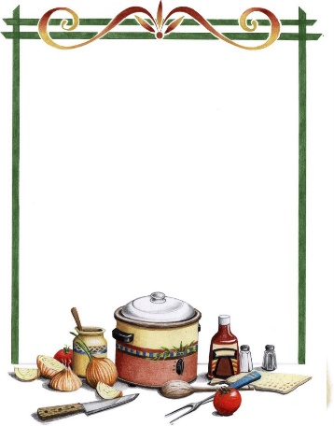

- I want to know, how clever you are. Do the sums and make some sentences to show how smart you are .

9-6+2= 4+2-0= 0+8-7=
5+2-4= 7-5+0= 8-6+2=
4+5-1= 8-5-3= 1+2+4=
6-2+5= 3+1+4= 5+1-3=

- Do,like, sweets,?, you
- Got,have,a , family, big, I
- My,can, and,swim,run,dog
- I, cheese, any, haven’t, got
- Have, blue, I, got , eyes

- Заключительный этап

So, we have sent 5 envelopes with information about us to our friends in space. I hope they will be happy to see it. Let our rocket fly!
Thank you for taking part! Goodbye!

